**EX:No.3 LINEAR REGRESSION 221501016 21/01/25**

**AIM :** To implement linear regression on a time series data .

**IMPLEMENTATION :**

import pandas as pd

from sklearn.model_selection import train_test_split

from sklearn.linear_model import LinearRegression

import matplotlib.pyplot as plt

**Load the dataset**

file_path = "Electric_Production.csv"

df = pd.read_csv(file_path)

**Convert DATE to a numerical format**

df["DATE"] = pd.to_datetime(df["DATE"])

df["DATE_ORDINAL"] = df["DATE"].map(pd.Timestamp.toordinal)

**Define features (X) and target variable (Y)**

X = df[["DATE_ORDINAL"]]

y = df["IPG2211A2N"]

**Split data into training and testing sets**

X_train, X_test, y_train, y_test = train_test_split(X, y, test_size=0.2, random_state=42)

**Train the linear regression model**

model = LinearRegression()

model.fit(X_train, y_train)

**Model coefficients**

print(f"Slope: {model.coef_[0]}")

print(f"Intercept: {model.intercept_}")

**Make predictions**

y_pred = model.predict(X_test)

**Plot the regression line**

plt.scatter(X_test, y_test, color='blue', label='Actual Data')

plt.plot(X_test, y_pred, color='red', linewidth=2, label='Regression Line')

plt.xlabel("Date (Ordinal)")

plt.ylabel("Electric Production")

plt.title("Simple Linear Regression on Electric Production Data")

plt.legend()

plt.show()

**OUTPUT:**

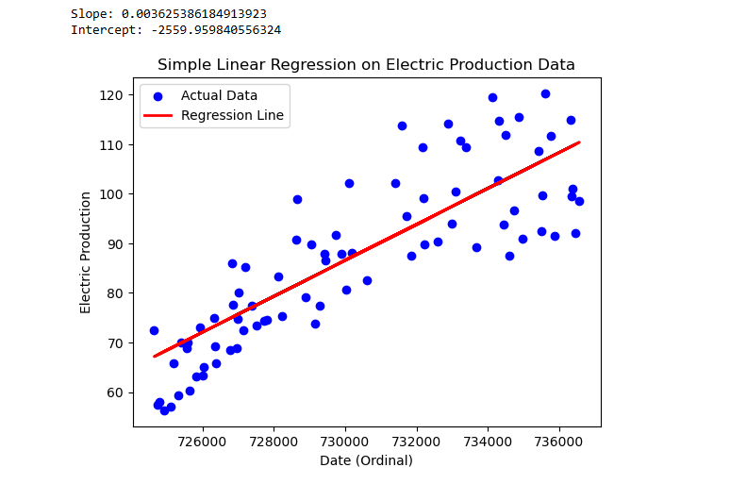

**RESULT :** Thus linear regression has been implemented on a time series data.